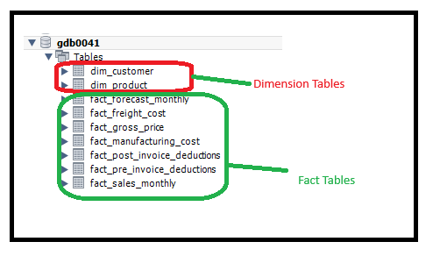

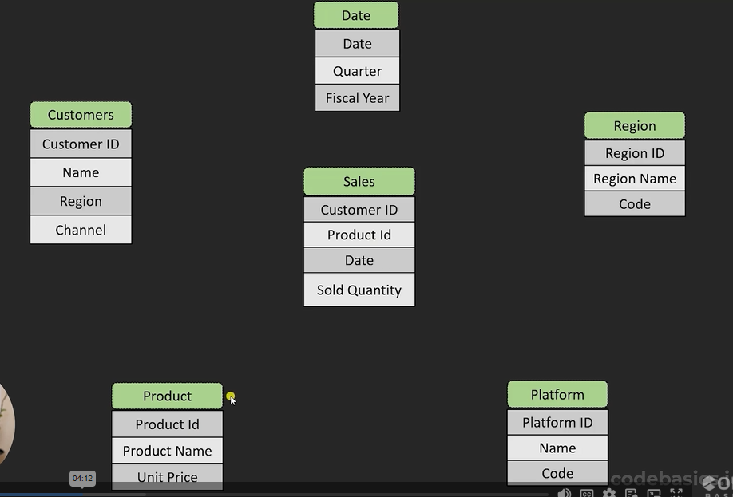

Star schema:
1. Fact table and dimension table
2. Dimension table amend info to fact table
3. Normalization & Denormalized
